 **Scientific Reports** https://doi.org/10.1038/s41598-023-44396-w 1

through data analysis has become critical for attracting and retaining customers, since it allows firms to anticipate probable reasons for customer turnover and take early actions to resolve them.

Traditional churn prediction methods frequently have scaling concerns. For machine learning classifiers, several studies rely on human feature engineering methods. Gupta et al.5 used KNN for classification in previous study. However, these models do not provide an effective method for identifying clients who are likely to depart the organization.

Deep learning (DL) is a new discipline of computer science that extracts patterns from past data and makes accurate predictions using feature embedding methods. DL has been used successfully in a variety of fields, including stock price forecasting, personality recognition, disease prediction, text categorization, and others. There is considerable interest in using DL to assist companies in accurately forecasting customer churn from historical data. As a result, it is critical to conduct research and use advanced DL approaches to customer data in order to accurately assess customer churn. As a result, in our research, we present a deep learning technique called BiLSTM-CNN. BiLSTM retains useful insights from the given Telco dataset context information in both the forward and backward directions5. Our major goal is to effectively categorize the data as churn or nonchurn using a BiLSTM-CNN model. Deep learning is used in this model to give more accurate and efficient churn prediction.

# The goal of the research

Numerous researchers1,4,5 have investigated the use of computational methodologies, specifically machine learning (ML) techniques, to forecast customer attrition. However, because the primary focus of these studies has been on early identification of customer turnover, they have encountered problems in dealing with the intricate interactions between predictor variables in customer churn. In this paper, we propose a novel hybrid deep learning model, BiLSTM + CNN, that combines bidirectional long/short-term memory (BiLSTM) and convolutional neural network (CNN) to predict customer turnover from a given dataset. This model aims to improve on the inadequacies of existing classifiers and forecast client turnover more accurately. We alleviate the limitation of the unidirectional LSTM layer’s insufficient context information by integrating the CNN layer. The CNN layer takes BiLSTM input and ensures adequate context information, allowing effective data categorization into the churn and non-churn categories. **Problem statement**

The churn identification task is a binary classification that seeks to separate churners from non-churners. The training data is denoted by P = {p1, p2, p3,…, pm}, and the associated class label is denoted by y, where *y*  {0, 1} . If y equals one, it denotes churn; otherwise, it represents non-churn. Our goal is to create a model that can accurately distinguish churn and non-churn based on the training data and class labels we provided.

**Research questions** *Research Questions:*

RQ.1: How to predict customer churn from the given dataset with the use of a hybrid deep neural network model?

RQ.2: What are the limitations of classical machine learning algorithms, and what is the efficiency of the hybrid deep neural network model as compared to classical machine learning classifiers?

RQ.3: What is the efficiency of the proposed hybrid model for customer churn prediction concerning similar studies?

# Research contributions

This study makes the following contributions:

* A composite deep learning model is used to predict client churn.
* The efficiency of various deep learning and machine learning models for predicting client attrition.
* Evaluation of the proposed model’s performance on a standard dataset for predicting customer attrition.

The remainder of the paper is structured as follows: The second portion reviews selected papers, the third section introduces the proposed technique, the fourth section analyses and assesses the results, and the last section proposes potential research avenues.

# Literature review

A literature review on Customer Churn Prediction is included in this section.

## A review of selected studies

The study conducted by 6 investigates staff attrition through the use of several machine learning models in order to improve customer satisfaction and retention. Using the IBM dataset, five basic models and three ensembles were created and analyzed. The linear model outperformed the others in terms of accuracy, recall, and AUC. The research conducted by7 employs big data analysis to develop an estimating model for customer attrition in

Vol:.(1234567890)

communication firms. For modelling, segmentation and regression approaches are used with good results. However, more system enhancements are required employs big data analysis to develop an estimating model for customer attrition in communication firms. For modelling, segmentation and regression approaches are used with good results. However, more system enhancements are required. Ranjan and Sood 8 investigated the application of Twitter sentiment analysis to forecast customer attrition in Indian telecommunications. For prediction, they used the Nave Bayes classifier and TextBlob, evaluated the models with IBM SPSS, and discovered positive results for increasing customer experience and retention. However, the restricted dataset need further expansion for more robust results. Jeyakarthic et al.9 developed an ML-based customer churn prediction model in a cloud computing setting. With 95.50 precision, 70.49 recall, 91.71 accuracy, 95.13 Fscore, and 67.20 kappa value, the model performed well. The study advises that feature selection and clustering approaches be used to improve the model further. Ahmad et al.10 used machine learning techniques on large amounts of data to create a client attrition prediction model for the telecom industry. The decision tree, random forest, gradientboosted machine tree, and extreme gradient-boosted machine tree techniques were all used in the model. The XGBOOST algorithm performed the best among them. Panjasuchat et al.11 used supervised learning datasets to implement reinforcement learning for customer churn prediction. When the data amount was increased, DQN beat XGBoost, Random Forest, and KNN. However, when the dataset pattern changed, the performance of all methods declined. Nguyen et al.12 investigated customer attrition in service industries and dealt with data imbalance issues. They contrasted SMOTE and Deep Belief Network with cost-sensitive data resampling approaches, weighted loss, and focal loss. In low turnover rate conditions, focal loss and weighted loss surpassed SMOTE and DBN in prediction performance. Wahul et al.13 used SGD, RF, GB, AdaBoost, and Stacking classifiers to create an ensemble learning architecture for churn prediction. The stacked model outperformed individual classifiers in identifying churn consumers due to better accuracy, recall, and AUC. The researchers recommend experimenting with advanced ensemble approaches and diverse data sources. Prabadevi et al.14 used nine months of customer data to examine machine-learning algorithms for early customer attrition prediction. In terms of accuracy, the Stochastic Gradient Booster surpassed other methods. For hyperparameter tweaking, the study recommends employing more complex optimization approaches. Thorat et al.15 investigated the effectiveness of deep learning in forecasting customer attrition in the telecom business. Algorithms such as Random Forest and XGBoost were used in the study. The deep learning model deployed achieved 88% accuracy, although more data and hyperparameter optimization could improve outcomes.

Saha et al.16 evaluated multiple learning approaches, including CNN and ANN, using two public datasets to construct a churn prediction model. On the first dataset, CNN obtained 99% accuracy and 98% on the second. For better prediction, the study proposed utilizing structured, unstructured, and behavioral data. Seymen et al.17 developed ANN and CNN models for predicting retail customer attrition and compared them to various machine learning algorithms. The deep learning-based CNN model beat the others, reaching 97.62% classification accuracy. The study advises employing AI technologies to investigate missing client behavior patterns. **Research gap and justification for using BiLSTM-CNN model for churn prediction**

While basic machine and deep learning techniques have shown efficacy in customer churn prediction, earlier research have struggled to achieve greater classification accuracy levels. Incorrect parameter and layer selection can have a major impact on neural network model performance. The suggested BiLSTM + CNN model will investigate a variety of layers and parameter values to solve customer attrition in the telecoms industry. In addition, we will run further deep learning model iterations and compare their outcomes to earlier research. The proposed approach, which combines bidirectional long-term short-term memory (BiLSTM) with multiplelayer convolutional neural networks (CNN), tries to effectively identify customer turnover using accessible data.

Here are some of the reasons why the suggested BiLSTM-CNN architecture is appropriate for churn prediction:

* Bidirectional LSTM: A bidirectional LSTM has two LSTM layers: one that processes the input sequence forward and one that processes the input sequence backward. This can help the model perform better on tasks where the order of the input sequence is essential. The order of the input sequence is significant in churn prediction because it can reveal patterns that suggest whether a client is likely to churn. For example, if a customer has lately made a big number of transactions, it could signal that they are happy with the service and are less likely to churn. However, if a customer has recently cancelled their service, it may suggest that they are dissatisfied with the service and are and are more likely to churn12.
* Convolutional Neural Network: A convolutional neural network (CNN) is a sort of neural network that works well with sequential data. CNNs can learn to extract features from input sequences and utilize them to produce predictions. CNNs can be used in churn prediction to extract information from a customer’s past data, such as their purchase history, service usage, and interactions with customer care. These characteristics can then be used to forecast if a customer is likely to churn18. In addition to the benefits listed above, the following are some additional advantages of employing BiLSTM-CNN for churn prediction:
* It can detect long-term dependencies in the input sequence: BiLSTM-CNN can detect long-term dependencies in the input sequence. This is significant for predicting customer turnover since customer churn is frequently driven by a set of events that occur over time. For example, a client may be unsatisfied with the service for some time before deciding to churn. These long-term dependencies can be captured by BiLSTM-CNN and used to produce more accurate predictions (20). It is relatively easy to train: BiLSTMCNN is relatively easy to train compared to other deep learning models. This is because BiLSTM-CNN has a relatively simple architecture19. Overall, the BiLSTM-CNN architecture is well-suited for churn

prediction since it can capture long-term dependencies in the input sequence, it is reasonably simple to train, and it has been demonstrated to be effective for churn prediction.



Churn dataset



acquision



Preprocessing



Applying deep



learning model



Applied example



for Customer



churn predicon

# Methodology

The suggested technique is divided into following modules (Fig. 1): (i) Churn dataset acquisition, (ii) preprocessing, (iii) Applying deep learning model, and (iv) Applied example for Customer churn prediction. . Each module’s specifics are provided below. **Churn dataset acquisition**

The goal of this study was to forecast client churn using telecom data and a series of calculations. We used a telecom dataset with 7033 rows and 20 different features to meet the needs of a telecom 20. The dataset was initially partitioned into two subsets to ease the building and assessment of predictive models using the traintest-split approach from the sklearn package. This procedure produced a training dataset including 80% of the samples and a testing dataset containing the remaining 20% of the samples. To achieve a well-balanced and representative data distribution for successful model assessment, the conventional 80–20 split was used.

## *Training dataset*

A training dataset is often required for the successful deployment of the suggested BiLSTM-CNN model. Typically, around 80% of the collected data is allocated for model training, though this amount may vary depending on the scenario. Datasets with appropriate labels are used to guide the hybrid neural network model during the model training phase. This labelled dataset is presented to the system in order for it to learn and improve its predicting capabilities. To use the proposed model for identifying customers who are likely to churn, data from the training dataset must be collected ahead of time. This preliminary phase guarantees that the model has the required knowledge to effectively anticipate churn for prospective clients.

## *Testing dataset*

The dataset enters the model testing phase once the model training is completed. It is critical to incorporate values from the training dataset into the testing dataset in order to evaluate the model’s learning performance. The enriched testing dataset is subsequently sent into the deep neural network for evaluation.

## *Organizing dataset*

The dataset was obtained and put in a machine-readable ".csv" file format for the telecom corporation Telco, making it compatible with various machine learning methods.

## Data Pre-processing

The data is pre-processed extensively for the model experiment, which includes a range of feature selection strategies and pre-processing methodologies. The following list summarizes the many steps included in the preprocessing pipeline.

Vol:.(1234567890)

*Data cleaning* Because the data we have is in string format, it cannot be used directly for further calculations. To address this, we converted the string data to numerical representation. The data had to be cleaned prior to this modification.

6

Vol:.(1234567890)

7 Vol.:(0123456789) 8

Vol:.(1234567890)

9

Vol.:(0123456789)

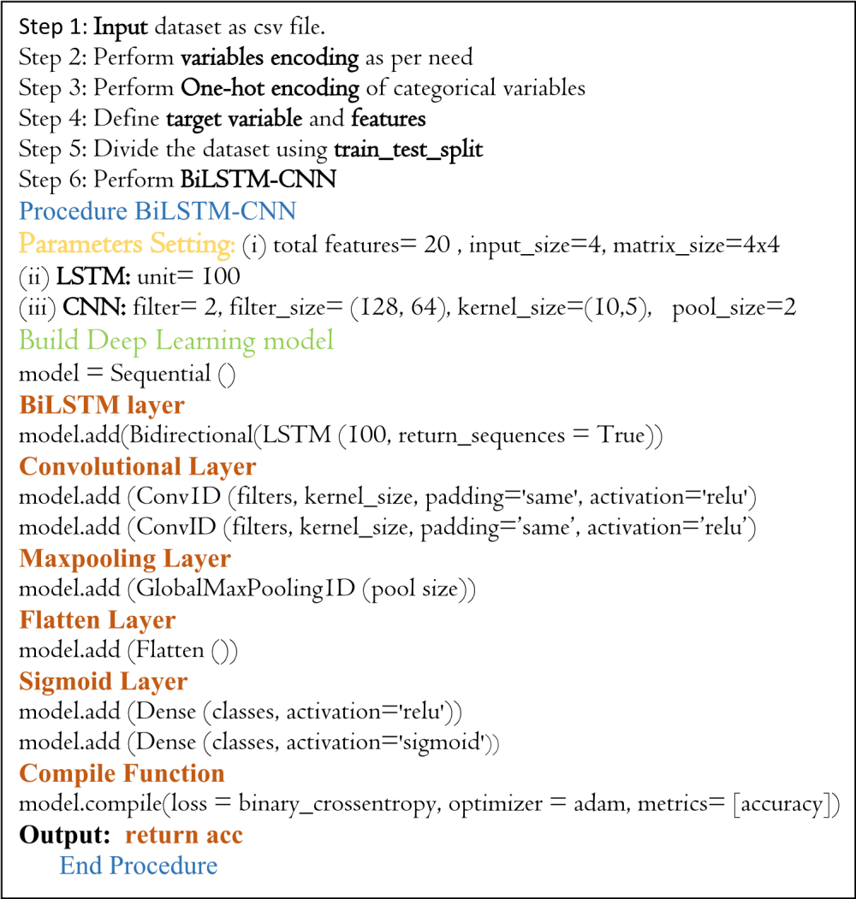

## Applied example

We ran a series of simulations using existing telecoms data to estimate client turnover (See Fig. 3) The dataset for this analysis was obtained from Kaggle.com and consists of 7033 rows with 20 features such as gender, senior citizen, partner, dependents, tenure, phone service, multiple lines, internet service, online security, online backup, device protection, tech support, streaming TV, streaming movies, contract, paperless billing, payment method, monthly charges, total charges, and churn. We extracted four particular features from this dataset and fed them into the BiLSTM-CNN model. The selected characteristics were first passed through the forward and reverse LSTM layers. After that, the outputs of both BiLSTM layers were merged and transmitted to the CNN layer for further processing.

The first step in CNN is filtering. First, we align the filter matrix, and then we do element-wise multiplication of the filter matrix with the selected patch of the sentence matrix in the second step. Finally, in the third stage, we compute the feature v2 by adding all of the values from the previous phase. The second phase in the CNN process is pooling. To begin, an acceptable window size is chosen, and then a stride is decided. To optimize pooling operations, we altered the window with a threshold. The stride controls how the window moves across the rectified feature map. In the third step, the previous stage’s window is used to select the maximum value, which serves as the pooling process’s output. We use flattening in the third stage of CNN to turn the pooled feature matrix into a feature vector. Following that, the client is classed as churn or non-churn based on the obtained features using the CNN layer’s classification algorithm. Each stage of the BiLSTM-CNN model is thoroughly investigated. We take a row from our dataset and present the step-by-step method to demonstrate the operation of the various layers in the proposed BiLSTM-CNN model for classifying the dataset as churn or nonchurn. *Data preparation*

Our approach attempts to anticipate which clients are likely to leave the organization. In our telecom dataset,

"C1" represents churn, while "C2" represents non-churn cases. The dataset contains 20 features that have all

**Scientific Reports** | (2023) 13:17294 | https://doi.org/10.1038/s41598-023-44396-w 10

Vol:.(1234567890)

been concatenated. We chose characteristics with non-zero values to prepare the data for examination. The Keras parser was used to convert the selected features into an index matrix. The matrix was then transferred to the

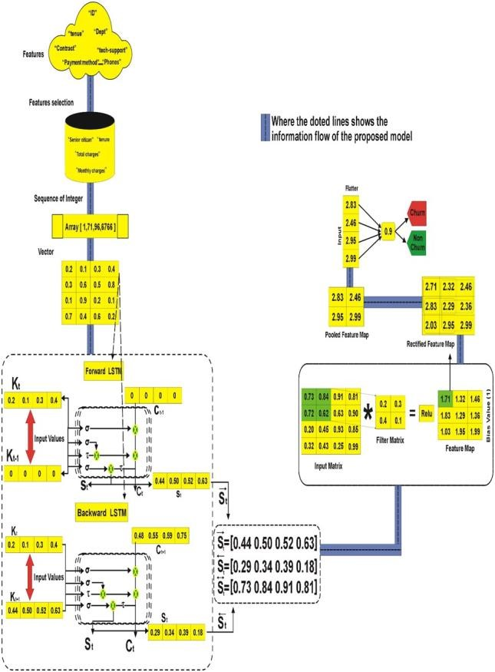

composite deep learning (DL) model’s embedding layer. The grading criteria include "SeniorCitizen," "tenure," "MonthlyCharges," and "TotalCharges." Each of these characteristics is transformed into a vector of floatingpoint values. A scalar embedding would be something like [1, 71, 96, 6766]. The matrix packaging produced the following result: [0.2, 0.1, 0.3, 0.4], [0.3, 0.6, 0.5, 0.8], [0.1, 0.9, 0.2, 0.1], [0.7, 0.4, 0.6, 0.2]. These values indicate the embeddings of the selected characteristics as streaming numbers.

### Contextual information extraction

Unidirectional LSTM can only access information from the prior context, which may not be sufficient for certain categorization tasks that require knowledge from both past and future contexts. To overcome this, we implemented a bidirectional architecture that makes use of both forward and backward LSTM. This enables us to process the sequence in both directions, acquiring extensive contextual information from the entire sequence, including elements from the past and future. The preceding neural network layer’s standardized feature map is utilized as input for this layer. The new candidate value (q–t), output gate (rt), forget gate (mt), and input gate (st) are the primary components of BILSTM layer calculations.

### Hidden layer 1

The current input (kt) and the previous state (St−1)) of the LSTM are used in the computation. The calculation is governed by Eqs. (1)–(6)−→. Finally, as the output of the first hidden layer, which corresponds to the forward pass LSTM, the hidden state ( *St* ) is obtained.

−→

*St rt vt* 0.44 1 0.48

0.50 1 0.55



= τ

0.52 1 0.59



12

Vol:.(1234567890)

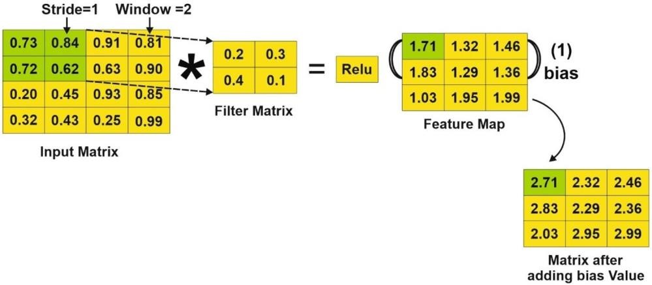



14

Vol.:(0123456789)

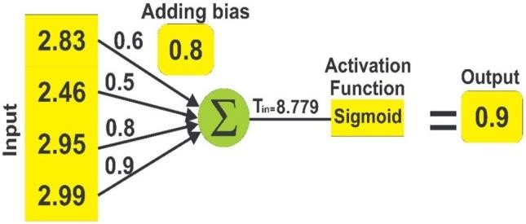

**Figure 7.** Final classification.

## Response to the initial research question

The initial research question is:

"How to predict customer churn from a given dataset by using a hybrid deep neural network model"

We used gender, SeniorCitizen, Partner, Dependents, tenure, PhoneService, MultipleLines, InternetService, OnlineSecurity, OnlineBackup, DeviceProtection, TechSupport, StreamingTV, StreamingMovies, Contract, PaperlessBilling, PaymentMethod, MonthlyCharges, TotalCharges, and churn from the customer’s dataset. These characteristics were fed into the BiLSTM-CNN model, which predicted which customers were likely to leave the telecom service. We ran several experiments using these characteristics to improve the performance of the hybrid model. Table 3 shows the various parameters of the proposed BiLSTM-CNN model.

We investigated several parameter choices for the variables in the BiLSTM-CNN model through a series of tests, measuring test loss, accuracy, and training time. Table 4 displays the results of the BiLSTM-CNN model, including training duration, test loss, and test accuracy. Among the several BiLSTM-CNN models, the "BiLSTMCNN (10)" model shines out, with filter sizes of 8 and 10, a number of filters of 60 and 50, and a BiLSTM unit length of 90 neurons, attaining an amazing accuracy of 81%. The various models were ranked based on their test accuracy, which ranged from 72 to 80%. Table 4 displays these data in ascending order.

### Precision, recall and F1 score of BiLSTM‑CNN

The accuracy, recall, precision, and f-score values of various BiLSTM-CNN models are shown in Table 5. Figure 8 also shows the evaluation measures for the BiLSTM-CNN models, such as precision, recall, and fscore. The recall, precision, and f-score values are represented on the X-axis, while the equivalent metrics for each of the BiLSTM-CNN models are shown on the Y-axis.

The mathematical equations Eqs. (18), (19) and (20) determine the recall, precision, and f-score, respectively. Figure 8 depicts a comparison of precision, recall, and f-score for the several variant models.

|  |  |  |  |  |  |  |
| --- | --- | --- | --- | --- | --- | --- |
| *Churn Correctly Identified* | | | |  |  |  |
| *Recall* =  *Churn correctly identified* + *Churn Incorrectly labeled as Non* − *Churn* *Churn Correctly identified* | | | |  |  | (18) |
| *Precision* =  *Churn correctly identified* + *indiviual incorrectly labeled as Churn* | | | |  |  | (19) |
| **Parameter** | **Value** |
| Sample size | 7033 |
| Total features | 20 |
| No of convolution layers | 2 |
| No of dense | 2 |
| BiLSTM unit size | 20, 50, 60, 60, 80, 60, 60, 100, 50,  90 |
| Activation function | Sigmoid |
| Optimizer | Adam |
| Dense size | 20, 1 |
| No of epochs | 10 |
| Batch size | 32 |

**Table 3.** Parameter setting of the proposed system.

16

Vol:.(1234567890)

|  |  |  |  |
| --- | --- | --- | --- |
| **Name of model** | **Recall** | **Precision** | **Fmeasure** |
| (1) BiLSTM-CNN | 0.03 | 0.70 | 0.05 |
| (2) BiLSTM-CNN | 0.09 | 0.84 | 0.16 |
| (3) BiLSTM-CNN | 0.18 | 0.70 | 0.29 |
| (4) BiLSTM-CNN | 0.18 | 0.78 | 0.29 |
| (5) BiLSTM-CNN | 0.25 | 0.73 | 0.37 |
| (6) BiLSTM-CNN | 0.31 | 0.71 | 0.43 |
| (7) BiLSTM-CNN | 0.29 | 0.76 | 0.42 |
| (8) BiLSTM-CNN | 0.39 | 0.72 | 0.50 |
| (9) BiLSTM-CNN | 0.62 | 0.64 | 0.63 |
| (10) BiLSTM-CNN | 0.64 | 0.66 | 0.65 |

*precision*  *recall*

*F* − *measure* =2 (20)

*precision* + *recall*

## Response to the second research question

The suggested BiLSTM-CNN model’s performance for customer churn prediction was thoroughly examined and compared to numerous traditional machine learning models (see Fig. 9). This comparison was carried out to answer the second research question, which investigates the limitations of classical machine learning methods and compares the efficiency of the hybrid deep neural network model to traditional machine learning classifiers. Table 6 compares the accuracy of the machine learning models to the proposed BiLSTM-CNN model.

### SVM (Support Vector Machine) vs. BiLSTM‑CNN (Proposed)

In comparison to the suggested model, SVM performed poorly in customer churn prediction, reaching an accuracy of only 76%. SVM is not well-suited for huge datasets, and its performance worsens when target classes overlap. Furthermore, SVM needs feature scaling, which might result in decreased accuracy. Furthermore, SVM performs badly when the number of attributes for each data sample exceeds the number of training data samples.

### Ensamble (Begging and Boosting) vs. BiLSTM‑CNN (Proposed)

In terms of customer turnover prediction, XBG attained a comparatively low accuracy of 79%. This reduced accuracy can be attributed to the fact that the XGB classifier takes a long time to learn and score. Furthermore, the limitation of only working with numerical features may limit its efficacy. Furthermore, if hyperparameters are not properly set, XGB can be prone to overfitting, reducing its predictive ability even further.

**Comparison of BiLSTM-CNN with Machine Learning Models**



0



%



20



%



40



%



60



%



80



%



%



100



**Bagging**



**Boosng**



**Decision Tree**



**KNN**



**Proposed BiLSTM**

**-**

**CN**



**N**



**F**

**-**

**Score**



**Recall**



**Precision**



**Accuracy**

**Figure 9.** Comparison of BiLSTM-CNN with machine learning models.

|  |  |  |  |  |  |
| --- | --- | --- | --- | --- | --- |
| **Study** | **Models** | **Accuracy**  **(%)** | **Precision**  **(%)** | **Recall**  **(%)** | **F-score**  **(%)** |
| Li and Zhou7 | SVM | 79 | 48 | 69 | 57 |
| Manghnani et al.22 | Bagging | 77 | 44 | 63 | 51 |
| Sari et al.23 | Boosting  (AdaBoost) | 72 | 36 | 50 | 42 |
| Herdian et al.24 | Decision Tree | 78 | 57 | 62 | 59 |
| Gupta et al.5 | KNN | 71 | 44 | 49 | 46 |
| Proposed | BiLSTM-CNN | 81 | 66 | 64 | 65 |

**Table 6.** Comparison with ML methods.

### Decision tree vs. BiLSTM‑CNN (Proposed)

In comparison to the proposed model, the decision tree performed poorly, with an accuracy of 78%. Due to the intrinsic intricacy of its calculations, decision trees often necessitate lengthier training periods. Furthermore, decision trees can become highly sophisticated, and even minor changes in the input might result in the formation of a whole new tree, making them potentially unstable. Furthermore, decision trees are ineffective when dealing with continuous numerical variables. *KNN (K Nearest Neighbor) vs. BiLSTM‑CNN (Proposed)*

The suggested BiLSTM-CNN model was compared to the KNN model. KNN performed poorly in predicting customer attrition, with an accuracy of only 71%. KNN’s shortcomings stem from its inability to handle bigger imbalanced datasets and its vulnerability to noisy data, missing values, and outliers, resulting in unsatisfactory accuracy. In contrast, the suggested BiLSTM-CNN model addresses classical machine learning difficulties such as manual feature extraction, restricted hyperparameter tuning capacity, and poor performance on large datasets. We can obtain better attrition prediction in the telecoms sector with higher accuracy and less processing time by using BiLSTM-CNN, making it a better alternative for customer churn prediction than KNN.

### Algorithm complexity of the proposed model

A BiLSTM-CNN model for churn prediction can be defined in terms of time and space complexity.

Time complexity. The number of operations executed during the training and prediction phases determines the time complexity of a BiLSTM-CNN model for churn prediction. The LSTM and CNN layers are the most significant contributors to time complexity. *LSTM Time Complexity*: A single LSTM cell has a time complexity of O(n), where n is the number of input features to the LSTM cell. This complexity is twice for a BiLSTM layer since it processes input in both forward and backward directions. The LSTM layer’s overall time complexity is O(T * n), where T is the number of time steps (sequence length) in the input data. *CNN Time Complexity:* The time complexity of a 1D Convolutional Neural Network (CNN) layer is determined by the kernel size, the number of filters (channels), and the length of the input sequence. Convolution takes O(k * n) operations for each filter, where k is the kernel size. The overall time complexity of the CNN layer is O(F * k * n) if there are F filters. *Overall Time Complexity:* The total temporal complexity of the BiLSTM-CNN model is the sum of the complexities of the BiLSTM and CNN layers, which can be written as: O(T * n) + O(F * k * n).

Vol:.(1234567890)

Space complexity. The number of parameters in the BiLSTM-CNN model, which includes weights, biases, and other trainable parameters, determines the space complexity of the model. Space Complexity of the BiLSTM layer is O(L * (4 * n * n + 4 * n)), where L is the number of LSTM cells (units) in the layer. CNN layer has a space complexity of O(F * (k * n + 1)), where F is the number of filters, k is the size of the kernel, and n is the number of input features. The BiLSTM-CNN model’s overall space complexity is the sum of the space complexities of the BiLSTM layer and the CNN layer, which can be expressed as: O(L * (4 * n * n + 4 * n)) + O(F * (k * n + 1)).

**Response to the Third Research Question:**

To answer the final RQ, "How effective is the proposed hybrid model for predicting customer churn in comparison to other DL models and similar studies?" We ran a series of tests to evaluate the effectiveness of the proposed BiLSTM-CNN for churn prediction to the findings of other studies.

### Comparison with Similar studies

Table 7shows the comparison of similar studies with the proposed model.

Gupta et al.5 used KNN model on customer turnover prediction, achieving and accuracy of 71% In comparison, our suggested model, BiLSTM-CNN, beat all of these feature selection approaches, as well as many other machine learning models, with an outstanding accuracy of 81% in predicting customer turnover.

### Comparison with other DL models

The study evaluated the BiLSTM + CNN model to other DL approaches such as CNN, RNN, and BiLSTM for predicting customer churn using prior customer data. The results are summarized in Table 8.

* CNN VS Proposed BiLSTM-CNN

The goal of this experiment was to compare the effectiveness of the proposed BiLSTM + CNN model to a mono CNN model. Based on the results in Table 8, it is clear that the CNN model performed the worst in terms of precision, recall, F1-score, and accuracy. The CNN model’s lower ranking can be attributable to two major factors: (i) its failure to maintain text sequence contextual information, and (ii) its need for a big dataset to improve classifier performance. • RNN VS Proposed BiLSTM-CNN

The aim of this study was to assess the effectiveness of the proposed BiLSTM + CNN model in comparison to an RNN model. As shown in Table 8, the RNN model exhibited inferior performance in terms of precision, recall, F1-score, and accuracy. The shortcomings of recurrent neural network models lie in their inability to retain information over extended time frames, as they struggle with managing excessively long patterns.

Consequently, the RNN model demonstrated unsatisfactory performance 3.

* BiLSTM VS Proposed BiLSTM-CNN

The purpose of this study was to compare the effectiveness of the suggested BiLSTM + CNN model to a regular BiLSTM model. As shown in Table 8, the BiLSTM model performed the worst in terms of accuracy, recall, F1-score, and precision. BiLSTM models’ shortcoming is their capacity to retain just past context information while ignoring future context information, which may provide a more comprehensive comprehension of the context in the reviewed text. As a result, it fared the worst of all the models tested.

# Conclusion and future work

To detect clients who are vulnerable to churn, this study applies a deep neural network dubbed BiLSTM-CNN. The following elements are included in the proposed BiLSTM-CNN model: (i) Collection of datasets; (ii) Preparation of datasets; (iii) Feature representation; (iv) Feature concatenation; and (v) Classification. When compared to the baseline procedures, the results show enhanced accuracy (81%), precision (66%), recall (64%), and f-score (65%). **Limitations**

This study has certain limitations, which are listed below: (i) it focused only on binary classification; (ii) The research will only use the BiLSTM-CNN model, without experimenting with other composite Deep Learning

|  |  |  |
| --- | --- | --- |
| **Study** | **Model** | **Accuracy** |
| Gupta et al.5 | KNN | 71% |
| Proposed | BiLSTMCNN | 81% |

**Table 7.** Comparison with baseline study.

|  |  |  |  |  |
| --- | --- | --- | --- | --- |
| **Deep learning model** | **Accuracy**  **(%)** | **Precision**  **(%)** | **Recall**  **(%)** | **F-score**  **(%)** |
| CNN | 75 | 64 | 63 | 64 |
| RNN | 76 | 62 | 54 | 63 |
| BiLSTM | 72 | 61 | 63 | 61 |
| Proposed Model (BiLSTM-CNN) | 81 | 66 | 64 | 65 |

**Table 8.** The suggested model (BiLSTM + CNN) versus other deep learning models.

models; (iii) Only numeric features will be used to predict customer attrition; (iv) The study will only use random feature embedding, without considering alternative representation models such as "pre-trained"; and (v) Given the dataset contains 20 features, more than twenty features should be used.

## Future work

The following study directions are suggested for the future: (i) To improve performance, researchers should conduct experiments on large-scale datasets and consider expanding the dataset to include varied domains. (ii) Future research should look into multidimensional CNN approaches and other deep neural network models for predicting customer churn. (iii) In future research, the suggested BiLSTM-CNN model should be used to tackle multiclass issues, multi-label classification, and imbalanced classification. (iv) Beyond numeric characteristics, more sorts of features should be researched to produce more efficient results. (v) In future research endeavors, pre-training feature embedding should be examined as a feasible technique.

# Data availability

Underlying data supporting the results can be provided by sending a request to the corresponding/submitting author.

Received: 15 May 2023; Accepted: 7 October 2023



# References

1. Dalli, A. Impact of hyperparameters on deep learning model for customer churn prediction in telecommunication sector. *Math. Probl. Eng.* **2022**, 1–11 (2022).
2. Kumar, S. & Chandarkala, D. A survey on customer churn prediction using machine learning techniques. *Int. J. Comput. Appl.* **154**(10), 13–16 (2016).
3. Rodan, A., Faris, H., Alsakran, J. & Al-Kadi, O. A support vector machine approach for churn prediction in telecom industry. *Int.*  *J. Inf.* **17**(8), 3961–3970 (2014).
4. Foju, S. W., Subramanian, S. & Khdr, M. H. Customer churn prediction in telecommunication industry using deep learning. *Inf. Sci. Lett.* **11**(1), 185–198 (2022).
5. Gupta, V. & Jatain, A. Artificial intelligence based predictive analysis of customer churn. *Formosa J. Comput. Inf. Sci.* **2**(1), 95– 110 (2023).
6. Qutub, A., Al-Mehmadi, A., Al-Hssan, M., Aljohani, R. & Aghamdi, H. S. Prediction of employee attrition using machine learning and ensemble methods. *Int. J. Mach. Learn. Comput.* **11**(2), 110–114 (2021). 7. Li, W. & Zhou, C. Customer churn prediction in telecom using big data analytics. *IOP Conf. Ser. Mater. Sci. Eng.* **768**(5), 1–6 (2020).
7. Ranjan, S. & Sood, S. Sentiment analysis based telecom churn prediction. *J. Web Eng. Technol.* **7**(1), 2455–1880 (2020).
8. Jeyakarthic, M. & Venkatesh, S. An effective customer churn prediction model using adaptive gain with back propagation neural network in cloud computing environment. *J. Res. Lepid.* **51**(1), 386–399 (2020).
9. Ahmad, A. K., Jafar, A. & Aljoumaa, K. Customer churn prediction in telecom using machine learning in big data platform. *J. Big Data* **6**(1), 1–24 (2019).
10. Panjasuchat, M. & Limpiyakorn, Y. Applying reinforcement learning for customer churn prediction. *J. Phys. Conf. Ser.* **1619**(1), 1–5 (2020).
11. Nguyen, N. N. & Duong, A. T. Comparison of two main approaches for handling imbalanced data in churn prediction problem. *J. Adv. Inf. Technol.* **12**(1), 29–35 (2021).
12. Wahul, R. M., Kale, A. P. & Kota, P. N. An ensemble learning approach to enhance customer churn prediction in telecom industry. *Int. J. Intell. Syst. Appl. Eng.* **11**(9), 258–266 (2023).
13. Prabadevi, B., Shalani, R. & Kavitha, B. R. Customer churning analysis using machine learning algorithms. *Int. J. Intell. Netw.* **4**, 145–154 (2023).
14. Thorat, A. S. & Sonawane, V. R. Customer churn prediction in the telecommunication industry using deep learning. *J. Data Acquis. Process.* **38**(3), 1417–1425 (2023).
15. Saha, L., Tripathy, H. K., Gaber, T., Gohary, H. & El-kenawy, E. M. Deep churn prediction method for telecommunication industry. *Sustainability* **15**(4543), 1–21 (2023).
16. Seymen, O. F., Olmez, E., Dogan, O., Orhan, E. R. & Hiziroglu, K. Customer churn prediction using ordinary artificial neural network and convolutional neural network algorithms: A comparative performance assessment. *J. Sci.* **36**(2), 720–733 (2023).
17. Alzahrani, A. & Asghar, M. Z. Intelligent risk prediction system in IoT-based supply chain management in logistics sector. *Electronics* **12**(13), 2760 (2023).
18. Jillani, N., Khattak, A. M., Asghar, M. Z. & Ullah, H. Efficient Diagnosis of Liver Disease using Deep Learning Technique. In *2023 IEEE International Symposium on Medical Measurements and Applications (MeMeA)* 1–6 (IEEE, 2023).
19. BlastChar. Telco Customer Churn. Available at[: https://www .kaggle .com /data sets /blas tchar /telco -cust omer -chur n (](https://www.kaggle.com/datasets/blastchar/telco-customer-churn)2018). Accessed 23 10 2022.
20. Alghazzawi, D., Rabie, O., Bamasaq, O., Albeshri, A. & Asghar, M. Z. Sensor-based human activity recognition in smart homes using depthwise separable convolutions. *Hum. Cent. Comput. Inf. Sci.* **12**, 50 (2022).

Vol:.(1234567890)

1. Manghnani, P., Kumari, U., Petakr, I. & Akadkar, A. Customer churn prediction. *Int. Multidiscip. Peer Rev. E J.* **8**(7), 259–292 (2023).
2. Sari, R. P., Febriyanto, F. & Adi, A. C. Analysis implementation of the ensemble algorithm in predicting customer churn in telco data: A comparative study. *Informatica* **47**, 63–70 (2023).
3. Herdian, R. & Girsang, A. S. Implementation of hybrid methods in data mining for predicting customer churn in the telecommunications sector. *J. Mant.* **7**(1), 216–228 (2023).

**Acknowledgements**

This research work was supported by Zayed University Policy Research Incentive Program.

# Author contributions

All authors listed have made a substantial, direct, and intellectual contribution to the work and approved it for publication.

**Funding**

This research work was supported by Zayed University Policy Research Incentive Program.

**Competing interests**

The authors declare no competing interests.

# Additional information

**Correspondence** and requests for materials should be addressed to M.Z.A.

**Reprints and permissions information** is available a[t www.nature.com/reprints.](http://www.nature.com/reprints)

**Publisher’s note** Springer Nature remains neutral with regard to jurisdictional claims in published maps and institutional affiliations.

**Open Access** This article is licensed under a Creative Commons Attribution 4.0 International

License, which permits use, sharing, adaptation, distribution and reproduction in any medium or

format, as long as you give appropriate credit to the original author(s) and the source, provide a link to the Creative Commons licence, and indicate if changes were made. The images or other third party material in this article are included in the article’s Creative Commons licence, unless indicated otherwise in a credit line to the material. If material is not included in the article’s Creative Commons licence and your intended use is not permitted by statutory regulation or exceeds the permitted use, you will need to obtain permission directly from the copyright holder. To view a copy of this licence, visit [http:// creat iveco mmons. org/ licen ses/ by/4. 0/.](http://creativecommons.org/licenses/by/4.0/)

© The Author(s) 2023